

EA SET TO LAUNCH Tiger Woods PGA TOUR,
Need for Speed Underground Rivals,
NFL Street 2: Unleashed & NBA STREET SHOWDOWN WITH the release of PSP™ (PlayStation®Portable).

Players Win with Four Hit EA Franchises,
Each Fully-Customized for the PSP.

Sydney, 10th August 2005: Electronic Arts will be releasing Tiger Woods PGA TOUR®, Need for Speed™ Underground Rivals, NFL STREET 2: Unleashed and NBA Street Showdown -- four of EA’s popular franchises are available in stores for the release of the PSP handheld entertainment system. All four EA games feature original game modes, head-to-head Wi-Fi multiplayer, unique content and turn-based Party Play. Several of the titles also feature EA™ POCKET TRAX a jukebox that allows gamers to transform their PSP into a music player by listening to the game’s soundtrack – and in some cases, watch music videos - when they are not even playing the game.

EA’s blockbuster line-up gives players the ultimate EA gaming experience, right in the palm of their hands. Each EA title has been specifically developed and optimized for the PSP by EA’s Team Fusion, an elite group of 150 developers, spanning two award-winning studios (EA Canada in Vancouver, B.C. and EA Tiburon in Orlando, Fl.)

“We knew that developing games for a smaller screen would be a challenge from both a playability and graphics standpoint, and would require bringing together a team of experts to get it right the first time,” said Warren Wall, Executive Producer and Director of EA’s Team Fusion. “The result of this collaboration is a gaming experience that doesn’t compromise on the details while raising the bar for quality with new feature sets across the entire line. We managed to exceed even our own expectations, and gamers will not be disappointed.”



Take on Tiger Woods and other golfing greats from past and present in Tiger Woods PGA TOUR® on the PSP. Create your own golfer, develop your skills, and step on to the green to challenge the masters on the world’s top courses. Play against Tiger Woods Vijay Singh, Jack Nicklaus, and Arnold Palmer, in an effort to become a golfing legend. Raise the stakes by playing wirelessly against your friends. Tiger Woods PGA TOUR® is the ultimate handheld golfing experience



Hit the neon streets of Need for Speed™ Underground Rivals in pursuit of total ownership of the tuner racing scene. In this first-ever Need for Speed title for the PSP, customize and build the ultimate tuner on four rims then take it into the underground world of street racing. With tons of tuning options, a variety of game modes, and the circuit’s most sought-after cars, Need for Speed Underground Rivals delivers an unrivalled tuner experience… in the palm of your hand.

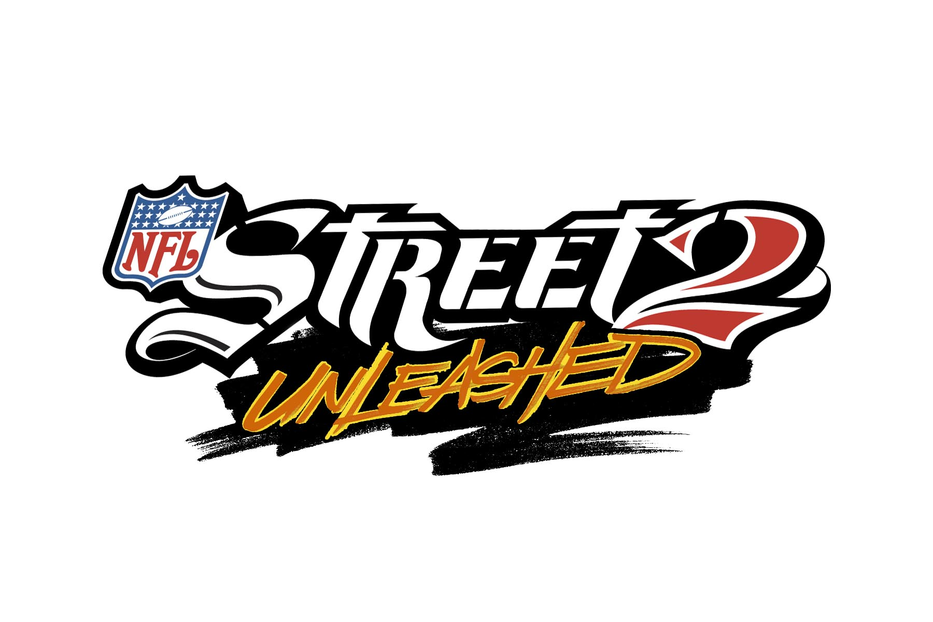

Defy gravity and stretch the world of arcade football to the skies with NFL STREET 2: Unleashed. NFL players are free from their real-world constraints to dominate the streets one stylin’ move and one field at a time. Raise your game to the limits with up-the-wall passes, off-the-wall catches, and highlight-reel wall jukes that are sure
to solidify your place as football’s greatest urban legend. With New Exclusive STREET Events, head-to-head wireless gameplay, NFL superstars and legends playing both sides of the ball, and new PSP-specific content, the time to own the streets is NOW.



Take your skills to a new level and challenge the greatest basketball icons to ever hit the court. With NBA STREET, tip off against the baddest old-school legends and today’s hottest players and rise above the rim with bigger-than-life moves. Defeat the best the streets have to offer with an arsenal of dunks, passes, dribbles, and tricks. Begin your journey to become a street legend with NBA STREET.

For more information on EA’s PSP line-up, please visit www.psp.ea.com

About PlayStation Portable™
PlayStation Portable is a new handheld entertainment system that allows users to enjoy 3D games, with high-quality full-motion video, and high-fidelity stereo audio. With graphics rendering capability comparable to that of PlayStation®2, PlayStation Portable features a 4.3 inch widescreen, high-resolution TFT display. PlayStation Portable also adopts a newly developed compact but high-capacity (1.8GB) optical disc, Universal Media Disc (UMD), as its storage medium. With a wide range of accessories and connectivity options, including Memory Stick Duo™, USB 2.0, IR port and Wireless LAN.

About Electronic Arts
Electronic Arts Inc. (EA), headquartered in Redwood City , California, is the world’s leading interactive entertainment software company. Founded in 1982, EA posted revenues of $2.96 billion for fiscal 2004. The company develops, publishes, and distributes interactive software worldwide for video game systems, personal computers and the Internet. In 2003, EA had 27 titles that sold more than one million copies. Electronic Arts markets its products under three brand names: EA SPORTS™, EA GAMES™ and EA SPORTS BIG™. EA's homepage and online game site is www.ea.com. More information about EA’s products and full text of press releases can be found on the Internet at http://info.ea.com.

Electronic Arts, EA, EA SPORTS, EA SPORTS BIG, EA GAMES, MVP Baseball and Need for Speed are trademarks or registered trademarks of Electronic Arts Inc. in the U.S. and/or other countries. FIFA, NFL, NBA, Tiger Woods and PGA TOUR are trademarks of their respective owners and used with permission. PlayStation is a registered trademark and PSP is a trademark of Sony Computer Entertainment Inc. All other trademarks are the property of their respective owners.

